Dear Parents,

Our teachers have decided to have weekly assemblies where information to students can be addressed. The teachers are building more and more into the weekly assemblies on Mondays in even weeks and Tuesdays in odd weeks. Ask your child about what goes on during the assemblies.

In the end of October, I was invited into many of our international classes to see what goes on, on a daily basis. I was glad to see both passionate learners and educators. I saw Dr. Bones in Science talking about animal bones, Halloween recipes where the teaching objective was imperative, children going on a fishing trip to catch words, Maths with a high level of differentiation from the educator, word knowledge based on drawing and spelling strategies and children painting how dance looks like. Ask the teacher if you want to come and visit.

Already now, we are asked by Cambridge International Examinations to start thinking about the Checkpoint tests. We have to do final entries for the tests in January/February 2014. The pupils sitting the tests will be informed and parents too. There is an ongoing process of assessment of the children on a daily basis, so the checkpoints are only meant as one of our evaluation tools before moving to a new programme.

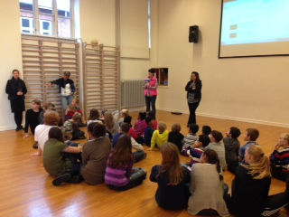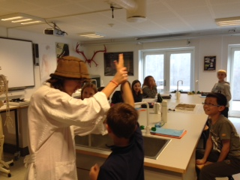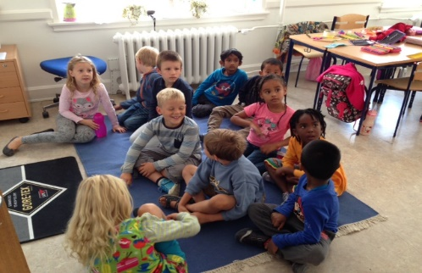

Newsletter from

the International

Department

*Skt. Josef’s School*

12

/

11

/

2013

N

o 2 school year 2013/2014

Dr. Bones in Science – P2

thank

our volunteers

for the help

we had on

F

riday

’

s cross country race. Wit

hout helpers

from the PTA

–

it

wouldn

’

t have been such a

success

.

Geraldine has been a key person in the planning and the

entire teacher

’

s team has helped a lot in the last minute

changes

and packing goodie

backs to 240 kids from 8

schools. The children

running the different distances from

500

m to 5km

did well and we n

ow know that every school

has wo

n

medals

.

Geraldine will announce the winners this

week.

Our next focus week is coming up very soon, please remember that

this school year and I know the teachers are working hard

on setting up different learning

experiences for our

P1 has school hours fr

om

8:15

-

1

pm and P2 and S1 from

8:15

-

. Frid

13:45

ay school

is dismissed at 12:15 and it is the day to wear sport

’

s gear

because it is our annual sport

’

s day.

Make sure to talk to your PTA representatives from each

class and be updated on what is going on

–

we

have

agreed to have 3 meetings

throughout

the school year and

the first one is scheduled for November 4 from 5

-

pm

6:30

**Important**

**!**

**Please write an email to**

**berit@sktjosef.dk**

**if your child has been**

**baptised**

**in**

**the**

**C**

**atholic**

**church**

Upcoming events

Upcoming Events

Focus week

November

throughout

October

10

th

Sport

’

s day October 11

th

Half term break October 14

th

throughout

18

th

November 22nd, teachers are leaving on our John Hattie course. Parent Subs are in. Schedule will be sent to you.

Focus week November 25th throughout November 29th